**Project Hydrate Life Due: 29 july**

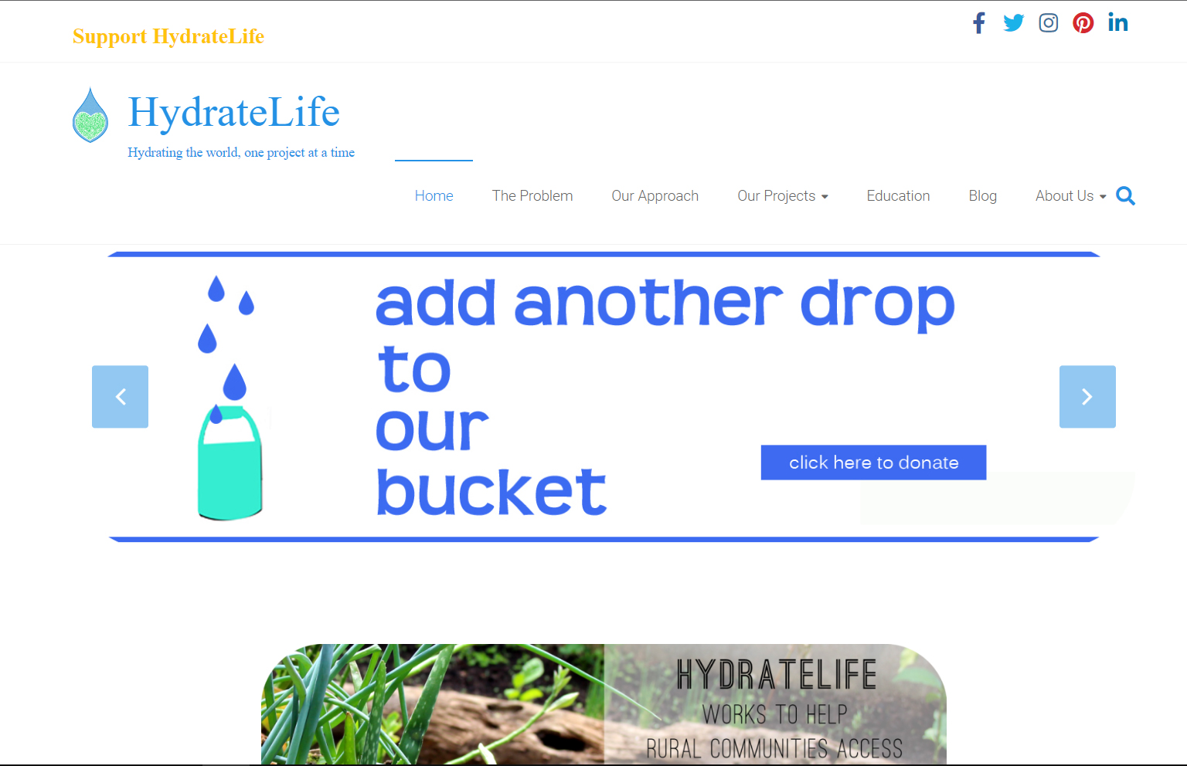

**Hydrate life**

Hydrate life is a non-profit organization that helps rural communities to get access to clean drinking water <https://www.hydratelife.org/>

Hydrate life wants a complete redesign of their website and want the new website to look clean and modern, with all of the latest trends in web design

You need to create a wireframe and mockup of the homepage and the problem content page

You then need to create the homepage, the problem and our approach pages in html and css using **CSS GRID**

**Peer Assessment**

Once completed your need to assess your peer’s website, complete an assessment form and give them feedback. For each category give a score out of 10

**Look and feel:** ___ / 10

**Layout and Structure of content:** ___ / 10

**Functionality:** ___ / 10

**Overall Usability:** ___ / 10

**Navigation:** ___ / 10

**Score:** ___ / 50

Your feedback on assessment:

What could have and needed to be done better: